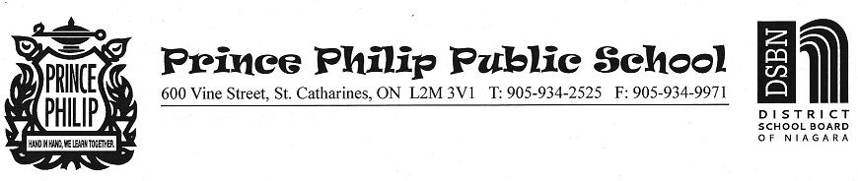
Dear Prince Philip Families:
As you are aware, the Ministry of Education announced that on Monday, April 19, instead of returning to in-person learning, schools will be moving to remote learning.
This means that all students will be engaging in learning with their homeroom and/or subject teachers online.
This decision was made in response to the rising COVID-19 cases, to keep students, staff, and our community safe.
If your child needs a device, please email Ashley.robinson@dsbn.org by the end of the day Monday, and we will make arrangements to provide one. As always, you are welcome to visit our school website “Families Getting Connected Online” tab to view tutorials that will support your access to the platforms we will be using.
Because this learning from home period is not anticipated to be a long one, we will not be allowing family/student access to the building to gather personal belongings except for emergency circumstances.
You will be contacted by your child’s homeroom teacher on Monday, April 19th, with more information.
We greatly appreciate your support as we move back into the online learning format. Though this isn’t how we had hoped to return from our break, we will work together in providing meaningful learning experiences while learning from home. We are confident in our practices and know our schools are safe places for staff and students, and we are looking forward to returning to in person learning as soon as possible.

Sincerely,

B. Baranoski, Principal

